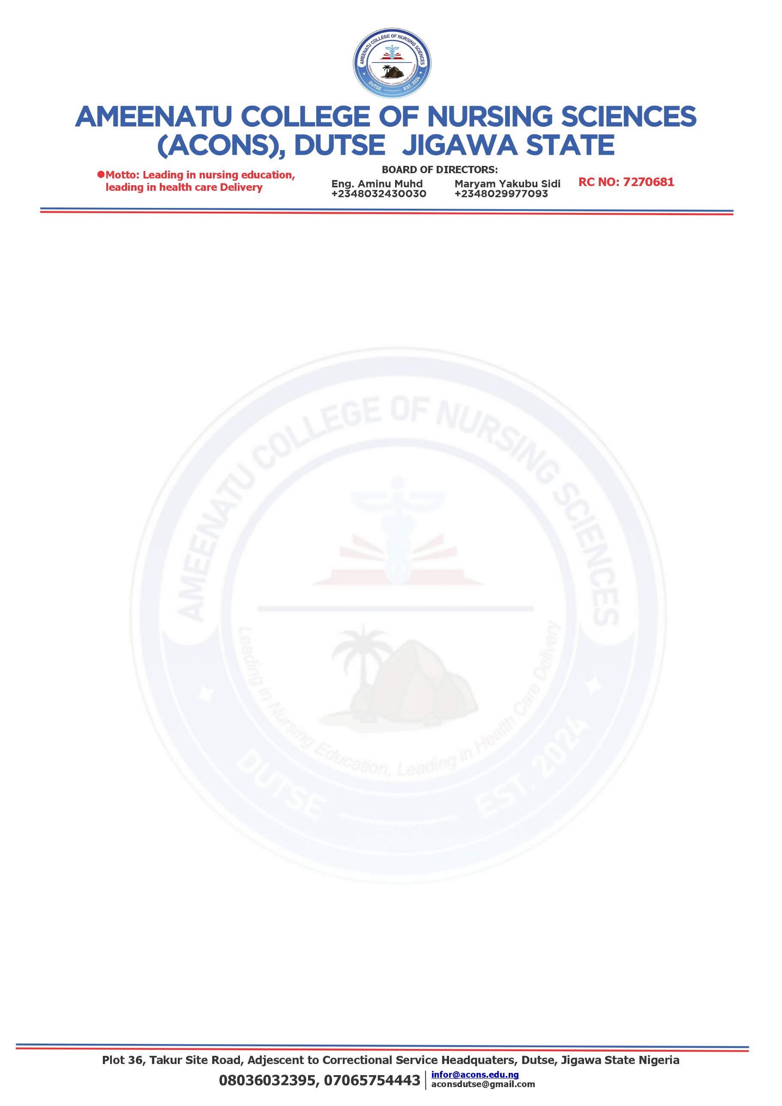
16th October, 2026

Admission Number: ……………………………….
Name of Candidate: ……………………………….
L.G.A: ………………………………………………
State: ………………………………………………..
Phone Number: …………………………………….

PROVISIONAL OFFER OF ADMISSION INTO ND/HND NURSING PROGRAM
(2026/2027 ACADEMIC SESSION)
Following your successful participation in the recent screening exercise, you have been offered provisional admission to a four-year ND/HND Nursing program at Ameenatu College of Nursing Sciences (ACONS), Dutse.
Conditions of Admission:
- Document verification:
You are required to present both the ORIGINAL and PHOTOCOPY of the following documents during registration.
- Primary School Leaving Certificate
- SSCE Statement/Certificate of results (WAEC, NECO, NABTEB or NBAIS), including the online printout
- Testimonial from your previous school
- Birth certificate or declaration of Age
- Medical Certificate of Fitness (Original)
- Two (2) recent passport-size photographs
- Disqualification Clause: If it is found at any point that you lack any of the required qualifications, your admission will be revoked immediately.
- Registration period: Registration will take place from Monday 19th October, 2026 to Friday 31st October, 2026. Failure to complete registration within this time frame will result in the cancellation of your admission.
- Name policy: Change of name is not permitted throughout the training period.
- Additional Requirements: A list of additional items required for registration is attached for your reference
- Commencement of lectures: …9th November, 2026…..
We look forward to welcoming you to the college. Congratulations!


Dr. Abdullahi Adamu
(Provost)

